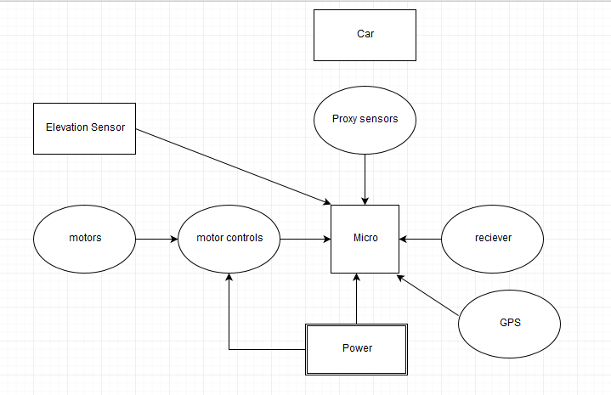

B

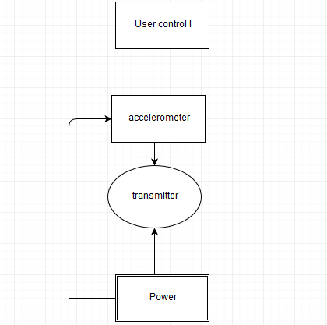









**Problem Definition**: create the controls& autonomous driving system that allows the user to operate the vehicle under difficult circumstances.

**Clarify objectives:**

* Develop the motion controls for operating the vehicle for people how are unable to use conventional controls.
* Implement proximity sensors to detect the objects that are in vehicle path to avoid collisions
* Develop elevation s detection system that regulate the speed up & down hill.
* Develop a parking stall/garage system that is able to determine if car is parked.

**Establish Matrix**:

* Able to read the user motion: tilting left /right or up/down. Which correlates to driving the car to turn left/right & forward or backward.
* Proximity sensors will measure distance between itself and the closest object in its path. Once the vehicle becomes close to the obstacle it will stop to avoid collision.
* The vehicle should be able to know whether it is travelling forwards or backwards and whether it’s front or back end is elevated with respect to a level orientation. Use this information to determine if the vehicle is travelling uphill or downhill then modify the motor control system to an appropriate operating point that will provide more power to travel uphill or prevent excessive speed when travelling downhill.
* The garage system will be able to detect if the vehicle is parked in the garage due to the change in capacitance that occurs between the walls of the garage when the car is inside.

**Identify Constraints:**

* User dexterity and ability to use motion controls will constrain the number of input controls. The tires on the vehicle cannot turn, they can only move forward/backwards.
* Proximity sensors will not be able to detect small objects or objects that are far away. It will not detect objects that are not in its travel path. It won’t be able to detect holes or ledges.
* The vehicle will not be able to climb steep hills.
* Being able to definitively detect whether the vehicle is in position.

**Additional Features:**

* Program the car to automatically pivot, back up or steer to avoid obstacles.
* Program the car to pursue an obstacle such as a soccer ball or a parking stall.
* Full circle pivot to make a complete proximity scan.
* Implement a GPS system to guide to car to a specific destination.
* Increasing user controls to a web interface or bluetooth headset.
* Use capacitor sensors to measure volume of material in the vehicles cargo section.